1. **Ingres networking is by default used in docker swarm.**
2. **There is by default load balancer (LB) present in Ingres network.**
3. **Due to Ingres networking multiple containers can listen on same port. Because request will first hit at LB and then get distributed.**
4. **If you wish you can create custom network which is called overlay network. But in this, LB is not used and traffic is also not encrypted.**

**# docker network create -d overlay test**

**To create custom network in swarm**



**# docker service create -d --network test nginx**

**To create new service with custom network**

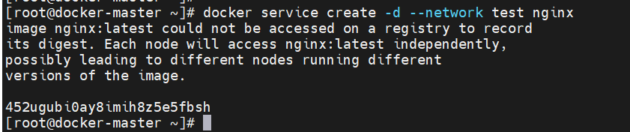

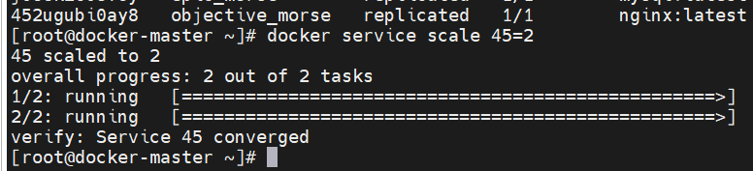

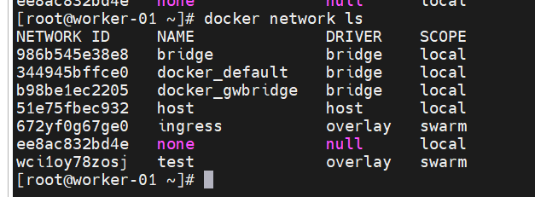

1. **# docker network create -d overlay --attachable test1**

**To create attachable network. You can use this network while manually creating any container on worker node. Because standard custom network is only work from master node.**

1. **Please note that if you are using port mapping and attaching custom network then that container will get attached with default ingress network as well because port mapping works on ingress network. Also gets attached with bridge network which is common for all in swarm.**